|  |  |  |
| --- | --- | --- |
| **Spring 2024** | **Report #1– 04/07/2024** | **Dingyi Nie** |

**——————————————————————————————————————**

**I. Task Achieved Last Week**

**——————————————————————————————————————**

* Prepared widely used and benchmarked (on GRU-D, mTAND, SeFT, RainDrop, ViTST etc.) real-world time series datasets (irregularly sampled and with missing values):
  + MIMIC-III: for ICU mortality prediction (binary classification);
  + PhysioNet Challenge 2012 (P12): for ICU mortality prediction (binary classification);
  + PhysioNet Challenge 2019 (P19): for Sepsis early prediction (binary classification);
  + PAMAP2 Physical Activity Monitoring (PAM): for human activity classification (multi-class classification).
* Cleaned the data, formatted them in the same formulation as in GRU-D, and stored them in a unified HDF5 format defined by me, which can be easily accessed and edited through h5py interface for imputation and downstream machine learning.
* Implemented basically everything discussed last week – FF imputing using Saab and k-means. Got the wholly imputed dataset for P19. As long as some other imputation methods (all-zero, all-mean, forward-fill, linear, cubic spline) for later comparison.

**——————————————————————————————————————**

**II. Feedback and Interaction**

**——————————————————————————————————————**

* **Prof. Kuo’s Feedback**

Placeholder

**——————————————————————————————————————**

**III. Report**

**——————————————————————————————————————**

A visualized imputed time series:

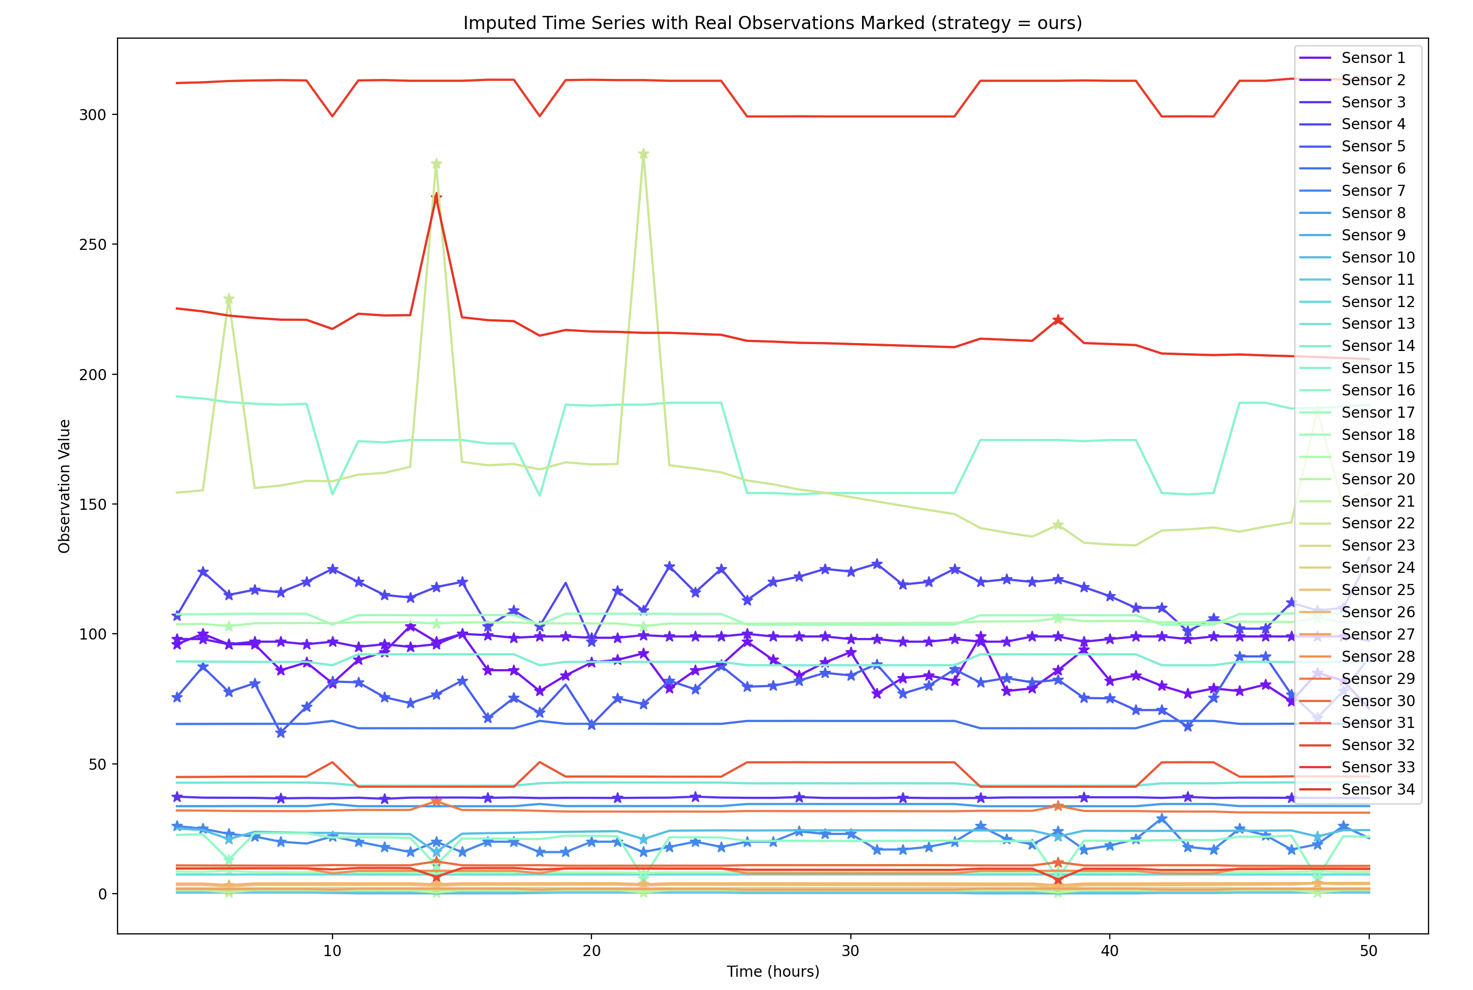

As comparison:

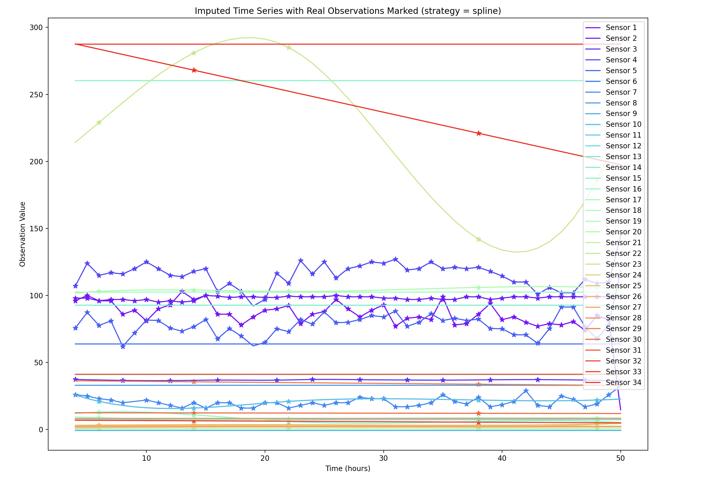

One observed problem: k-means is an offline algorithm. For incoming new samples (e.g. samples in test set), we don’t know which cluster to assign to.

Codes are available here:

**——————————————————————————————————————**

**IV. Next Steps**

——————————————————————————————————————

* Complete the full pipeline of Green Learning for modeling irregular time series with missingness. Test the classification performance against competitors.

**——————————————————————————————————————**

**V. Milestone**

——————————————————————————————————————

* As stated in I.